Bài tập thực hành 04

Lập trình PHP nâng cao

Mục tiêu cần đạt:
Sau buổi các bạn cần nắm thao tác sử dụng PHP nâng cao
- Hiểu và biết cách dùng Cookies và Session
- Tạo form đăng nhập và dùng cookies, session để quản lý các đăng nhập, thực hiện chức năng log out (thoát) khỏi hệ thống
- Biết về SQL Injection.
- Upload file, lưu thông tin về tập tin trong CSDL
- Đọc, và xử lý nội dung trong tập tin

Các bạn đọc và thực hiện viết code như hướng dẫn để làm quen, sau đó đọc trả lời các Yêu cầu ở dưới bài hướng dẫn để thực hiện yêu cầu bài thực hành.

Gợi ý Tham khảo:
- https://www.w3schools.com/php/
- và các nguồn khác mà sinh viên tìm được

Tạo Cookies
Cookies và Session hỗ trợ chúng ta quản lý các phiên đăng nhập/đăng nhập, hoạt động của người dùng trên các website
Tạo tập tin sử dụng khởi tạo cookies ck.php sau:

ck.php

<!DOCTYPE html>
<?php
$cookie_name = "user";
$cookie_value = "Nguyen Thanh Hai";
setcookie($cookie_name, $cookie_value, time() + (86400 / 24), "/"); // 86400 = 24*3600 = 1 day
?>
<html>
<body>

<?php
if(!isset($_COOKIE[$cookie_name])) {
echo "Cookie named '" . $cookie_name . "' chua duoc thiet lap, ban vui long bam f5 de thiet lap cookie!";
} else {
echo "Cookie '" . $cookie_name . "' da duoc thiet lap!<br>";
echo "Gia tri la: " . $_COOKIE[$cookie_name];
}
?>

<p><strong>Note:</strong> You might have to reload the page to see the value of the cookie.</p>

</body>
</html>

Tạo 1 trang đăng ký người dùng với mật khẩu được mã hóa
Tạo csdl qlbanhang, với bảng customers đầu tiên như sau:

CREATE TABLE `customers` (
`id` int(6) UNSIGNED NOT NULL,
`fullname` varchar(50) CHARACTER SET latin1 NOT NULL,
`email` varchar(50) CHARACTER SET latin1 DEFAULT NULL,
`Birthday` date DEFAULT NULL,
`reg_date` timestamp NOT NULL DEFAULT current_timestamp() ON UPDATE current_timestamp(),
`password` varchar(50) NOT NULL
) ENGINE=InnoDB DEFAULT CHARSET=utf8;

Tạo formnhap.php

formnhap.php
<!DOCTYPE HTML>
<html>
<body>

<form action="luu.php" method="post">
Name: <input type="text" name="name"><br>
E-mail: <input type="text" name="email"><br>
Birthday: <input type="date" name="birth"><br>
Password: <input type="password" name="pass"><br>

<input type="submit">
</form>

</body>
</html>
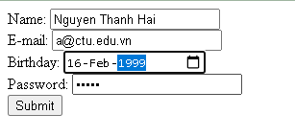

Và luu.php, chú ý lúc này chúng ta sẽ mã hóa mật khẩu với giải thuật md5 để bảo mật mật khẩu:

luu.php
<?php
$servername = "localhost";
$username = "root";
$password = "";
$dbname = "qlbanhang";

// Create connection
$conn = new mysqli($servername, $username, $password, $dbname);
// Check connection
if ($conn->connect_error) {
die("Connection failed: " . $conn->connect_error);
}

$date = date_create($_POST["birth"]);

$sql = "INSERT INTO customers (fullname, email, birthday, password)
VALUES ('".$_POST["name"] ."', '".$_POST["email"] ."', '".$date ->format('Y-m-d') ."','".md5($_POST["pass"])."' )";

if ($conn->query($sql) == TRUE) {
echo "Them sinh vien thanh cong";
} else {
echo "Error: " . $sql . "<br>" . $conn->error;
}

$conn->close();
?>

Sau khi chúng ta nhập xong mật khẩu với 12345 nhưng khi quan sát trong CSDL ta sẽ thấy mật khẩu đã được mã hóa ra chuỗi 827ccb0eea8a706c4c34a16891f84e7b:
Trong trường hợp chúng ta muốn dùng email là username để đăng nhập ta nên đảm bảo 2 student không có email trùng nhau. Để đảm bảo điều này ta có thể chọn email là unique key (vì ta đã chọn id la primary key, và 1 bảng không thể có 2 khóa chính)

ALTER TABLE `customers` ADD UNIQUE( `email`);

Tạo form đăng nhập
Sau khi tạo người dùng xong, ta có thể chạy form đăng nhập với username là email và password lấy từ CSDL

Login.php
<!DOCTYPE HTML>
<html>
<body>

<form action="log.php" method="post">
Username: <input type="text" name="email"><br>
Password: <input type="password" name="pass"><br>

<input type="submit">
</form>

</body>
</html>

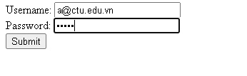

Log.php
<?php
$servername = "localhost";
$username = "root";
$password = "";v b
$dbname = "qlbanhang";

// Create connection
$conn = new mysqli($servername, $username, $password, $dbname);
// Check connection
if ($conn->connect_error) {
die("Connection failed: " . $conn->connect_error);
}

$sql = "select fullname, email from customers where email = '".$_POST["email"]."' and password = '".md5($_POST["pass"])."'";

$result = $conn->query($sql);

if ($result->num_rows > 0) {
echo "Dang nhap thanh cong <br>";
$row = $result->fetch_assoc();
echo "email:".$row['email']. ' Fullname: '.$row['fullname'];

} else {
echo "Error: " . $sql . "<br>" . $conn->error;
}

$conn->close();
?>

Khi chúng ta nhập sai, nhìn vào thông báo lỗi ta thấy
Mật khẩu đã cho không khớp với mã đã băm
Khi ta nhập đúng
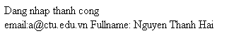

Dùng Cookies lưu lại tên đăng nhập, email và điều hướng
Chỉnh sửa lại log.php với code sau để khi đăng nhập thành công chuyển sang 1 trang chủ, còn nếu không đúng thì trở lại trang đăng nhập

Log.php (modified)
<?php
$servername = "localhost";
$username = "root";
$password = "";
$dbname = "qlbanhang";

// Create connection
$conn = new mysqli($servername, $username, $password, $dbname);
// Check connection
if ($conn->connect_error) {
die("Connection failed: " . $conn->connect_error);
}

$sql = "select id, fullname, email from customers where email = '".$_POST["email"]."' and password = '".md5($_POST["pass"])."'";

$result = $conn->query($sql);

if ($result->num_rows > 0) {

$row = $result->fetch_assoc();

$cookie_name = "user";
$cookie_value = $row['email'] ;
setcookie($cookie_name, $cookie_value, time() + (86400 / 24), "/");
setcookie("fullname", $row['fullname'], time() + (86400 / 24), "/");
setcookie("id", $row['id'], time() + (86400 / 24), "/");

header('Location: homepage.php');

} else {
echo "Error: " . $sql . "<br>" . $conn->error;
//Tro ve trang dang nhap sau 3 giay
header('Refresh: 3;url=login.php');

}

$conn->close();
?>

Tạo 1 trang chủ để khi đăng nhập thành công chuyển qua trang chủ này:

Homepage.php

<!DOCTYPE html>
<html>
<title>W3.CSS Template</title>
<meta charset="UTF-8">
<meta name="viewport" content="width=device-width, initial-scale=1">
<link rel="stylesheet" href="https://www.w3schools.com/w3css/4/w3.css">
<link rel="stylesheet" href="https://fonts.googleapis.com/css?family=Roboto">
<link rel="stylesheet" href="https://fonts.googleapis.com/css?family=Montserrat">
<link rel="stylesheet" href="https://cdnjs.cloudflare.com/ajax/libs/font-awesome/4.7.0/css/font-awesome.min.css">
<style>
.w3-sidebar a {font-family: "Roboto", sans-serif}
body,h1,h2,h3,h4,h5,h6,.w3-wide {font-family: "Montserrat", sans-serif;}
</style>
<body class="w3-content" style="max-width:1200px">

<!-- Sidebar/menu -->
<nav class="w3-sidebar w3-bar-block w3-white w3-collapse w3-top" style="z-index:3;width:250px" id="mySidebar">
<div class="w3-container w3-display-container w3-padding-16">
<i onclick="w3_close()" class="fa fa-remove w3-hide-large w3-button w3-display-topright"></i>
<h3 class="w3-wide"><b>
<?php
$cookie_name = "fullname";
echo 'Chao ban '.$_COOKIE[$cookie_name];

?>

</b></h3>
</div>
<div class="w3-padding-64 w3-large w3-text-grey" style="font-weight:bold">
<a href="#" class="w3-bar-item w3-button">Shirts</a>
<a href="#" class="w3-bar-item w3-button">Dresses</a>

<div id="demoAcc" class="w3-bar-block w3-hide w3-padding-large w3-medium">
<a href="#" class="w3-bar-item w3-button w3-light-grey"><i class="fa fa-caret-right w3-margin-right"></i>Skinny</a>
<a href="#" class="w3-bar-item w3-button">Relaxed</a>
<a href="#" class="w3-bar-item w3-button">Bootcut</a>
<a href="#" class="w3-bar-item w3-button">Straight</a>
</div>
<a href="#" class="w3-bar-item w3-button">Jackets</a>
<a href="#" class="w3-bar-item w3-button">Gymwear</a>
<a href="#" class="w3-bar-item w3-button">Blazers</a>
<a href="#" class="w3-bar-item w3-button">Shoes</a>
</div>
<a href="#footer" class="w3-bar-item w3-button w3-padding">Contact</a>
<a href="javascript:void(0)" class="w3-bar-item w3-button w3-padding" onclick="document.getElementById('newsletter').style.display='block'">Newsletter</a>
<a href="#footer" class="w3-bar-item w3-button w3-padding">Subscribe</a>
</nav>

<!-- Top menu on small screens -->
<header class="w3-bar w3-top w3-hide-large w3-black w3-xlarge">
<div class="w3-bar-item w3-padding-24 w3-wide">LOGO</div>
<a href="javascript:void(0)" class="w3-bar-item w3-button w3-padding-24 w3-right" onclick="w3_open()"><i class="fa fa-bars"></i></a>
</header>

<!-- Overlay effect when opening sidebar on small screens -->
<div class="w3-overlay w3-hide-large" onclick="w3_close()" style="cursor:pointer" title="close side menu" id="myOverlay"></div>

<!-- !PAGE CONTENT! -->
<div class="w3-main" style="margin-left:250px">

<!-- Push down content on small screens -->
<div class="w3-hide-large" style="margin-top:83px"></div>

<!-- Top header -->
<header class="w3-container w3-xlarge">

<p class="w3-right">
<i class="fa fa-shopping-cart w3-margin-right"></i>
<i class="fa fa-search"></i>
</p>
</header>

<div class="w3-container w3-text-grey" id="jeans">
<p>8 items</p>
</div>

<!-- Subscribe section -->
<div class="w3-container w3-black w3-padding-32">
<h1>Subscribe</h1>
<p>To get special offers and VIP treatment:</p>
<p><input class="w3-input w3-border" type="text" placeholder="Enter e-mail" style="width:100%"></p>
<button type="button" class="w3-button w3-red w3-margin-bottom">Subscribe</button>
</div>

<!-- Footer -->
<footer class="w3-padding-64 w3-light-grey w3-small w3-center" id="footer">
<div class="w3-row-padding">
<div class="w3-col s4">
<h4>Contact</h4>
<p>Questions? Go ahead.</p>
<form action="/action_page.php" target="_blank">
<p><input class="w3-input w3-border" type="text" placeholder="Name" name="Name" required></p>
<p><input class="w3-input w3-border" type="text" placeholder="Email" name="Email" required></p>
<p><input class="w3-input w3-border" type="text" placeholder="Subject" name="Subject" required></p>
<p><input class="w3-input w3-border" type="text" placeholder="Message" name="Message" required></p>
<button type="submit" class="w3-button w3-block w3-black">Send</button>
</form>
</div>

<div class="w3-col s4">
<h4>About</h4>
<p><a href="#">About us</a></p>
<p><a href="#">We're hiring</a></p>
<p><a href="#">Support</a></p>
<p><a href="#">Find store</a></p>
<p><a href="#">Shipment</a></p>
<p><a href="#">Payment</a></p>
<p><a href="#">Gift card</a></p>
<p><a href="#">Return</a></p>
<p><a href="#">Help</a></p>
</div>

<div class="w3-col s4 w3-justify">
<h4>Store</h4>
<p><i class="fa fa-fw fa-map-marker"></i> Company Name</p>
<p><i class="fa fa-fw fa-phone"></i> 0044123123</p>
<p><i class="fa fa-fw fa-envelope"></i> ex@mail.com</p>
<h4>We accept</h4>
<p><i class="fa fa-fw fa-cc-amex"></i> Amex</p>
<p><i class="fa fa-fw fa-credit-card"></i> Credit Card</p>
<br>
<i class="fa fa-facebook-official w3-hover-opacity w3-large"></i>
<i class="fa fa-instagram w3-hover-opacity w3-large"></i>
<i class="fa fa-snapchat w3-hover-opacity w3-large"></i>
<i class="fa fa-pinterest-p w3-hover-opacity w3-large"></i>
<i class="fa fa-twitter w3-hover-opacity w3-large"></i>
<i class="fa fa-linkedin w3-hover-opacity w3-large"></i>
</div>
</div>
</footer>

<div class="w3-black w3-center w3-padding-24">Powered by <a href="https://www.w3schools.com/w3css/default.asp" title="W3.CSS" target="_blank" class="w3-hover-opacity">w3.css</a></div>

<!-- End page content -->
</div>

<!-- Newsletter Modal -->
<div id="newsletter" class="w3-modal">
<div class="w3-modal-content w3-animate-zoom" style="padding:32px">
<div class="w3-container w3-white w3-center">
<i onclick="document.getElementById('newsletter').style.display='none'" class="fa fa-remove w3-right w3-button w3-transparent w3-xxlarge"></i>
<h2 class="w3-wide">NEWSLETTER</h2>
<p>Join our mailing list to receive updates on new arrivals and special offers.</p>
<p><input class="w3-input w3-border" type="text" placeholder="Enter e-mail"></p>
<button type="button" class="w3-button w3-padding-large w3-red w3-margin-bottom" onclick="document.getElementById('newsletter').style.display='none'">Subscribe</button>
</div>
</div>
</div>

<script>
// Accordion
function myAccFunc() {
var x = document.getElementById("demoAcc");
if (x.className.indexOf("w3-show") == -1) {
x.className += " w3-show";
} else {
x.className = x.className.replace(" w3-show", "");
}
}

// Click on the "Jeans" link on page load to open the accordion for demo purposes
document.getElementById("myBtn").click();

// Open and close sidebar
function w3_open() {
document.getElementById("mySidebar").style.display = "block";
document.getElementById("myOverlay").style.display = "block";
}

function w3_close() {
document.getElementById("mySidebar").style.display = "none";
document.getElementById("myOverlay").style.display = "none";
}
</script>

</body>
</html>

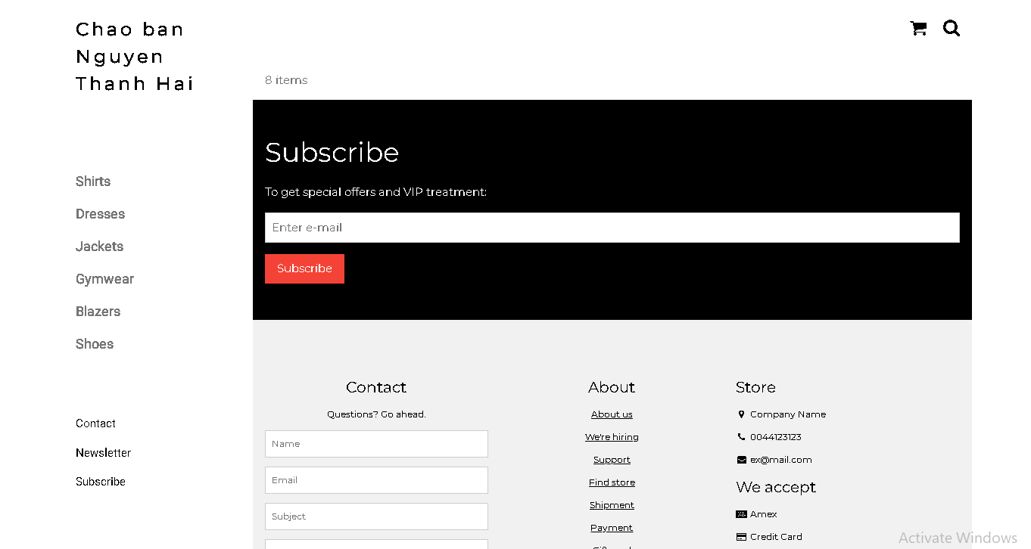

Upload tập tin
Upload file, chúng ta tạo form giao diện để upload file ảnh upload-img.php

Upload-img.php

<!DOCTYPE html>
<html>
<body>

<form action="upload.php" method="post" enctype="multipart/form-data">
Ban chon 1 anh de lam profile:
<input type="file" name="fileToUpload" id="fileToUpload">
<input type="submit" value="Upload Image" name="submit">
</form>

</body>
</html>

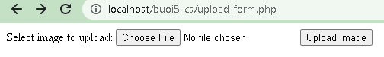

Tập tin upload.php xử lý hành động

upload.php

<?php
$target_dir = "uploads/";
$target_file = $target_dir . basename($_FILES["fileToUpload"]["name"]);
$uploadOk = 1;
$imageFileType = strtolower(pathinfo($target_file,PATHINFO_EXTENSION));

// Check if image file is a actual image or fake image
if(isset($_POST["submit"])) {
$check = getimagesize($_FILES["fileToUpload"]["tmp_name"]);
if($check !== false) {
echo "File is an image - " . $check["mime"] . ".";
$uploadOk = 1;
} else {
echo "File is not an image.";
$uploadOk = 0;
}
}

// Check if file already exists
if (file_exists($target_file)) {
echo "Sorry, file already exists.";
$uploadOk = 0;
}

// Check file size
if ($_FILES["fileToUpload"]["size"] > 500000) {
echo "Sorry, your file is too large.";
$uploadOk = 0;
}

// Allow certain file formats
if($imageFileType != "jpg" && $imageFileType != "png" && $imageFileType != "jpeg"
&& $imageFileType != "gif" ) {
echo "Sorry, only JPG, JPEG, PNG & GIF files are allowed.";
$uploadOk = 0;
}

// Check if $uploadOk is set to 0 by an error
if ($uploadOk == 0) {
echo "Sorry, your file was not uploaded.";
// if everything is ok, try to upload file
} else {
if (move_uploaded_file($_FILES["fileToUpload"]["tmp_name"], $target_file)) {
echo "The file ". htmlspecialchars( basename( $_FILES["fileToUpload"]["name"])). " has been uploaded.";
} else {
echo "Sorry, there was an error uploading your file.";
}
}
?>

Sau khi chúng ta upload thành công giao diện sau sẽ hiển thị
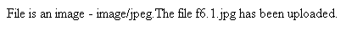

Upload ảnh và lưu dữ liệu về ảnh trong CSDL

Trong phần này chúng ta minh họa tải tập tin ảnh làm ảnh profile của người dùng

Upload-img.php (modified)
<!DOCTYPE html>
<html>
<body>

<form action="upload-csdl.php" method="post" enctype="multipart/form-data">
Ban chon 1 anh de lam profile:
<input type="file" name="fileToUpload" id="fileToUpload">
<input type="submit" value="Upload Image" name="submit">
</form>

</body>
</html>

Thêm cột để lưu đường dẫn ảnh:

ALTER TABLE `customers` ADD `img_profile` VARCHAR(100);

Upload-csdl.php

<?php
$target_dir = "uploads/";
$target_file = $target_dir . basename($_FILES["fileToUpload"]["name"]);
$uploadOk = 1;
$imageFileType = strtolower(pathinfo($target_file,PATHINFO_EXTENSION));

// Check if image file is a actual image or fake image
if(isset($_POST["submit"])) {
$check = getimagesize($_FILES["fileToUpload"]["tmp_name"]);
if($check !== false) {
echo "File is an image - " . $check["mime"] . ".";
$uploadOk = 1;
} else {
echo "File is not an image.";
$uploadOk = 0;
}
}

// Check if file already exists
if (file_exists($target_file)) {
echo "Sorry, file already exists.";
$uploadOk = 0;
}

// Check file size
if ($_FILES["fileToUpload"]["size"] > 500000) {
echo "Sorry, your file is too large.";
$uploadOk = 0;
}

// Allow certain file formats
if($imageFileType != "jpg" && $imageFileType != "png" && $imageFileType != "jpeg"
&& $imageFileType != "gif" ) {
echo "Sorry, only JPG, JPEG, PNG & GIF files are allowed.";
$uploadOk = 0;
}

// Check if $uploadOk is set to 0 by an error
if ($uploadOk == 0) {
echo "Sorry, your file was not uploaded.";
// if everything is ok, try to upload file
} else {
if (move_uploaded_file($_FILES["fileToUpload"]["tmp_name"], $target_file)) {
echo "The file ". htmlspecialchars( basename( $_FILES["fileToUpload"]["name"])). " has been uploaded.";
echo '<br>';

$servername = "localhost";
$username = "root";
$password = "";
$dbname = "qlbanhang";

// Create connection
$conn = new mysqli($servername, $username, $password, $dbname);
// Check connection
if ($conn->connect_error) {
die("Connection failed: " . $conn->connect_error);
}

$id = $_COOKIE['id'];
$sql = "UPDATE customers set img_profile = '".$_FILES["fileToUpload"]["name"]."'";
$sql = $sql. " WHERE ID='".$id."'";

echo $sql;
if ($conn->query($sql) == TRUE) {
echo 'cap nhat csdl thanh cong!<br>';
echo '<a href="homepage.php">Trang chu</a>';
} else {
echo "Error: " . $sql . "<br>" . $conn->error;
}

} else {
echo "Sorry, there was an error uploading your file.";
}
}
?>

Homepage.php (modified với ảnh profile)

<!DOCTYPE html>
<html>
<title>W3.CSS Template</title>
<meta charset="UTF-8">
<meta name="viewport" content="width=device-width, initial-scale=1">
<link rel="stylesheet" href="https://www.w3schools.com/w3css/4/w3.css">
<link rel="stylesheet" href="https://fonts.googleapis.com/css?family=Roboto">
<link rel="stylesheet" href="https://fonts.googleapis.com/css?family=Montserrat">
<link rel="stylesheet" href="https://cdnjs.cloudflare.com/ajax/libs/font-awesome/4.7.0/css/font-awesome.min.css">
<style>
.w3-sidebar a {font-family: "Roboto", sans-serif}
body,h1,h2,h3,h4,h5,h6,.w3-wide {font-family: "Montserrat", sans-serif;}
</style>
<body class="w3-content" style="max-width:1200px">

<!-- Sidebar/menu -->
<nav class="w3-sidebar w3-bar-block w3-white w3-collapse w3-top" style="z-index:3;width:250px" id="mySidebar">
<div class="w3-container w3-display-container w3-padding-16">
<i onclick="w3_close()" class="fa fa-remove w3-hide-large w3-button w3-display-topright"></i>
<h3 class="w3-wide"><b>
<?php
$cookie_name = "fullname";
echo 'Chao ban '.$_COOKIE[$cookie_name];

//them doan nay de lay duong dan anh
$servername = "localhost";
$username = "root";
$password = "";
$dbname = "qlbanhang";

// Create connection
$conn = new mysqli($servername, $username, $password, $dbname);
// Check connection
if ($conn->connect_error) {
die("Connection failed: " . $conn->connect_error);
}

$sql = "select img_profile from customers where id = '".$_COOKIE['id']."'";
//echo $sql;
$result = $conn->query($sql);

//print_r($result);
if ( $result->num_rows > 0) {
//lay link anh tu csdl da luu de hien thi cac anh duoc luu trong uploads
$row = $result->fetch_assoc();
echo '<img src="'.'./uploads/'.$row['img_profile'].'" alt="Anh profile">';
}
?>

</b></h3>
</div>
<div class="w3-padding-64 w3-large w3-text-grey" style="font-weight:bold">
<a href="#" class="w3-bar-item w3-button">Shirts</a>
<a href="#" class="w3-bar-item w3-button">Dresses</a>

<div id="demoAcc" class="w3-bar-block w3-hide w3-padding-large w3-medium">
<a href="#" class="w3-bar-item w3-button w3-light-grey"><i class="fa fa-caret-right w3-margin-right"></i>Skinny</a>
<a href="#" class="w3-bar-item w3-button">Relaxed</a>
<a href="#" class="w3-bar-item w3-button">Bootcut</a>
<a href="#" class="w3-bar-item w3-button">Straight</a>
</div>
<a href="#" class="w3-bar-item w3-button">Jackets</a>
<a href="#" class="w3-bar-item w3-button">Gymwear</a>
<a href="#" class="w3-bar-item w3-button">Blazers</a>
<a href="#" class="w3-bar-item w3-button">Shoes</a>
</div>
<a href="#footer" class="w3-bar-item w3-button w3-padding">Contact</a>
<a href="javascript:void(0)" class="w3-bar-item w3-button w3-padding" onclick="document.getElementById('newsletter').style.display='block'">Newsletter</a>
<a href="#footer" class="w3-bar-item w3-button w3-padding">Subscribe</a>
</nav>

<!-- Top menu on small screens -->
<header class="w3-bar w3-top w3-hide-large w3-black w3-xlarge">
<div class="w3-bar-item w3-padding-24 w3-wide">LOGO</div>
<a href="javascript:void(0)" class="w3-bar-item w3-button w3-padding-24 w3-right" onclick="w3_open()"><i class="fa fa-bars"></i></a>
</header>

<!-- Overlay effect when opening sidebar on small screens -->
<div class="w3-overlay w3-hide-large" onclick="w3_close()" style="cursor:pointer" title="close side menu" id="myOverlay"></div>

<!-- !PAGE CONTENT! -->
<div class="w3-main" style="margin-left:250px">

<!-- Push down content on small screens -->
<div class="w3-hide-large" style="margin-top:83px"></div>

<!-- Top header -->
<header class="w3-container w3-xlarge">

<p class="w3-right">
<i class="fa fa-shopping-cart w3-margin-right"></i>
<i class="fa fa-search"></i>
</p>
</header>

<div class="w3-container w3-text-grey" id="jeans">
<p>8 items</p>
</div>

<!-- Subscribe section -->
<div class="w3-container w3-black w3-padding-32">
<h1>Subscribe</h1>
<p>To get special offers and VIP treatment:</p>
<p><input class="w3-input w3-border" type="text" placeholder="Enter e-mail" style="width:100%"></p>
<button type="button" class="w3-button w3-red w3-margin-bottom">Subscribe</button>
</div>

<!-- Footer -->
<footer class="w3-padding-64 w3-light-grey w3-small w3-center" id="footer">
<div class="w3-row-padding">
<div class="w3-col s4">
<h4>Contact</h4>
<p>Questions? Go ahead.</p>
<form action="/action_page.php" target="_blank">
<p><input class="w3-input w3-border" type="text" placeholder="Name" name="Name" required></p>
<p><input class="w3-input w3-border" type="text" placeholder="Email" name="Email" required></p>
<p><input class="w3-input w3-border" type="text" placeholder="Subject" name="Subject" required></p>
<p><input class="w3-input w3-border" type="text" placeholder="Message" name="Message" required></p>
<button type="submit" class="w3-button w3-block w3-black">Send</button>
</form>
</div>

<div class="w3-col s4">
<h4>About</h4>
<p><a href="#">About us</a></p>
<p><a href="#">We're hiring</a></p>
<p><a href="#">Support</a></p>
<p><a href="#">Find store</a></p>
<p><a href="#">Shipment</a></p>
<p><a href="#">Payment</a></p>
<p><a href="#">Gift card</a></p>
<p><a href="#">Return</a></p>
<p><a href="#">Help</a></p>
</div>

<div class="w3-col s4 w3-justify">
<h4>Store</h4>
<p><i class="fa fa-fw fa-map-marker"></i> Company Name</p>
<p><i class="fa fa-fw fa-phone"></i> 0044123123</p>
<p><i class="fa fa-fw fa-envelope"></i> ex@mail.com</p>
<h4>We accept</h4>
<p><i class="fa fa-fw fa-cc-amex"></i> Amex</p>
<p><i class="fa fa-fw fa-credit-card"></i> Credit Card</p>
<br>
<i class="fa fa-facebook-official w3-hover-opacity w3-large"></i>
<i class="fa fa-instagram w3-hover-opacity w3-large"></i>
<i class="fa fa-snapchat w3-hover-opacity w3-large"></i>
<i class="fa fa-pinterest-p w3-hover-opacity w3-large"></i>
<i class="fa fa-twitter w3-hover-opacity w3-large"></i>
<i class="fa fa-linkedin w3-hover-opacity w3-large"></i>
</div>
</div>
</footer>

<div class="w3-black w3-center w3-padding-24">Powered by <a href="https://www.w3schools.com/w3css/default.asp" title="W3.CSS" target="_blank" class="w3-hover-opacity">w3.css</a></div>

<!-- End page content -->
</div>

<!-- Newsletter Modal -->
<div id="newsletter" class="w3-modal">
<div class="w3-modal-content w3-animate-zoom" style="padding:32px">
<div class="w3-container w3-white w3-center">
<i onclick="document.getElementById('newsletter').style.display='none'" class="fa fa-remove w3-right w3-button w3-transparent w3-xxlarge"></i>
<h2 class="w3-wide">NEWSLETTER</h2>
<p>Join our mailing list to receive updates on new arrivals and special offers.</p>
<p><input class="w3-input w3-border" type="text" placeholder="Enter e-mail"></p>
<button type="button" class="w3-button w3-padding-large w3-red w3-margin-bottom" onclick="document.getElementById('newsletter').style.display='none'">Subscribe</button>
</div>
</div>
</div>

<script>
// Accordion
function myAccFunc() {
var x = document.getElementById("demoAcc");
if (x.className.indexOf("w3-show") == -1) {
x.className += " w3-show";
} else {
x.className = x.className.replace(" w3-show", "");
}
}

// Click on the "Jeans" link on page load to open the accordion for demo purposes
document.getElementById("myBtn").click();

// Open and close sidebar
function w3_open() {
document.getElementById("mySidebar").style.display = "block";
document.getElementById("myOverlay").style.display = "block";
}

function w3_close() {
document.getElementById("mySidebar").style.display = "none";
document.getElementById("myOverlay").style.display = "none";
}
</script>

</body>
</html>

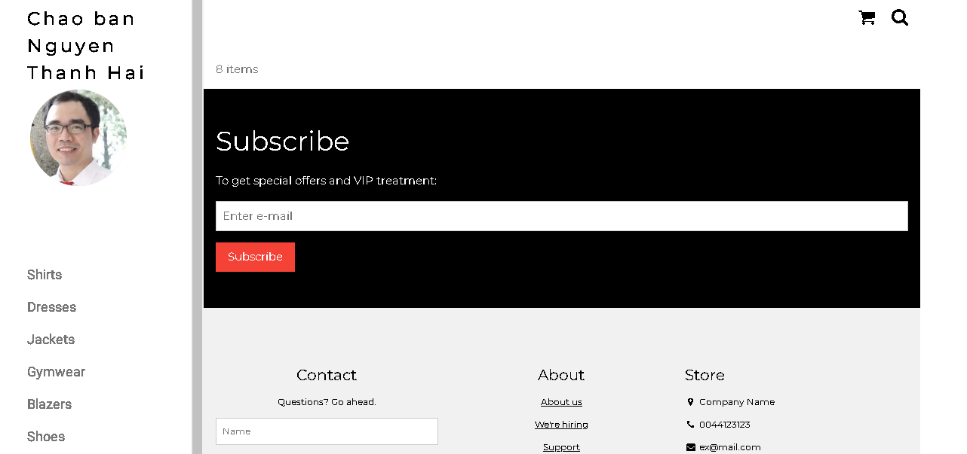

Ở đây do biểu diễn từng bước nên đoạn này chúng ta lấy dữ liệu link ảnh profile từ id của người dùng. Trong thực tế, các bạn có thể lưu link ảnh profile vào cookie/session ngay từ khi đăng nhập.

Upload file csv và đọc dữ liệu vào mảng
Thao tác đọc dữ liệu từ các tập tin là quan trọng, giúp chúng ta backup dữ liệu và phục hồi hay import dữ liệu từ các hệ thống khác. Ví dụ dưới đây giúp minh họa cho các bạn thao tác đọc dữ liệu từ tập tin csv và từ đó đưa vào mảng để phục vụ cho việc xử lý.

read-csv.php
<?php
$csv = array();
$name_file = 'cus.csv';
$lines = file($name_file, FILE_IGNORE_NEW_LINES);

//dua du lieu tu file csv vao mang:
foreach ($lines as $key => $value)
{
$csv[$key] = str_getcsv($value);
}

//in mang
echo '<pre>';
print_r($csv);
echo '</pre>';
?>
Tạo tập tin cus.csv với dữ liệu như sau
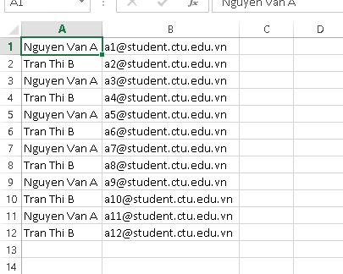
Khi chạy code đọc trên ta sẽ có dữ liệu đã được đưa vào mảng và hiển thị

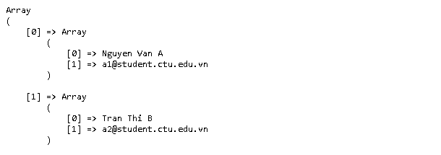

Yêu cầu bài thực hành:
- Bạn hãy chạy tất cả các lệnh hướng dẫn ở trên và chụp lại màn hình kết quả.
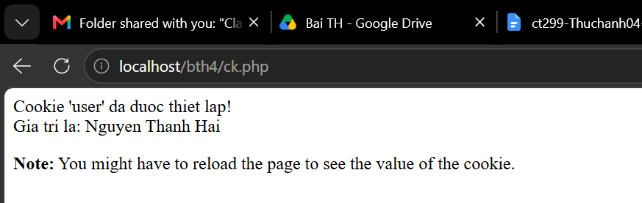
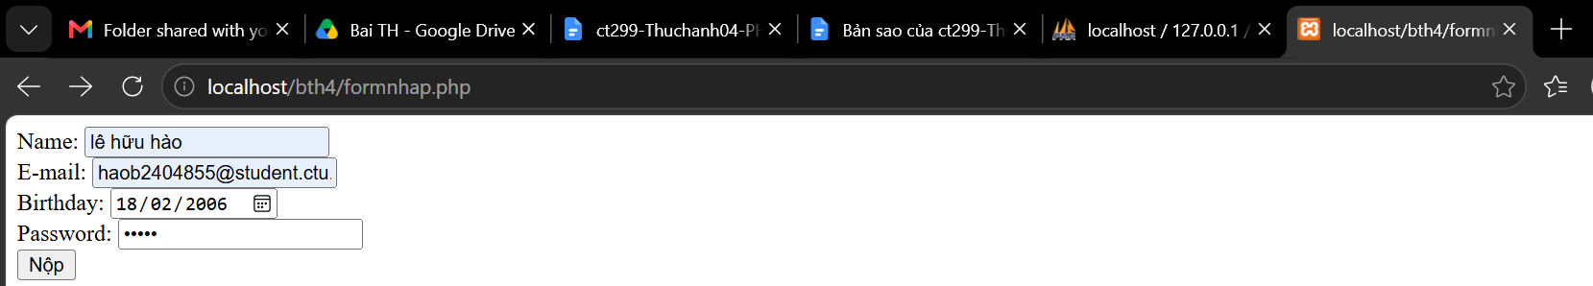
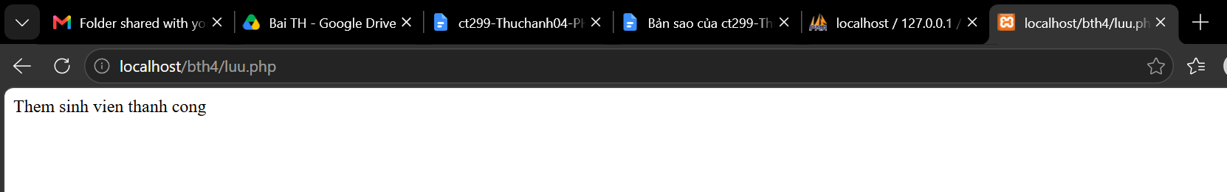

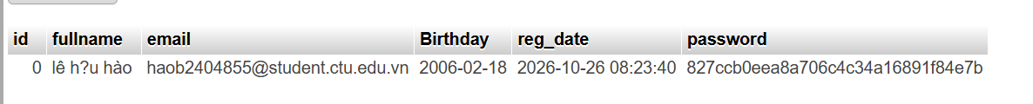
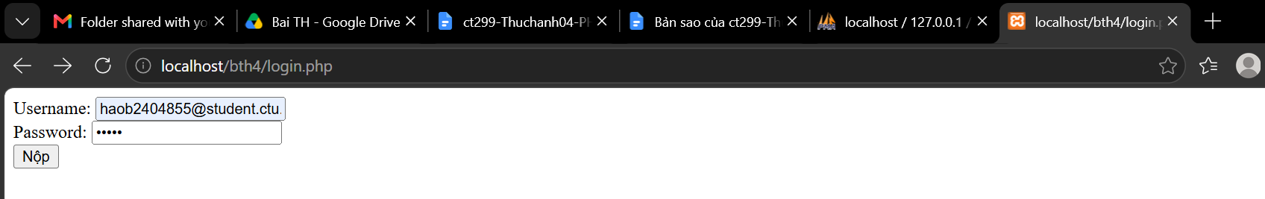
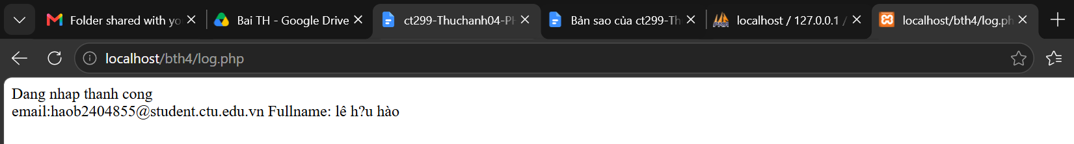
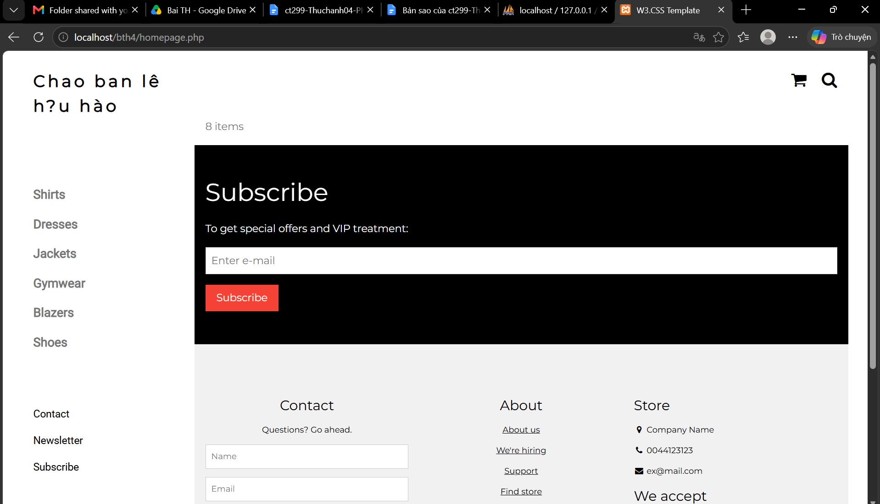
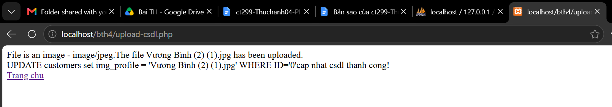
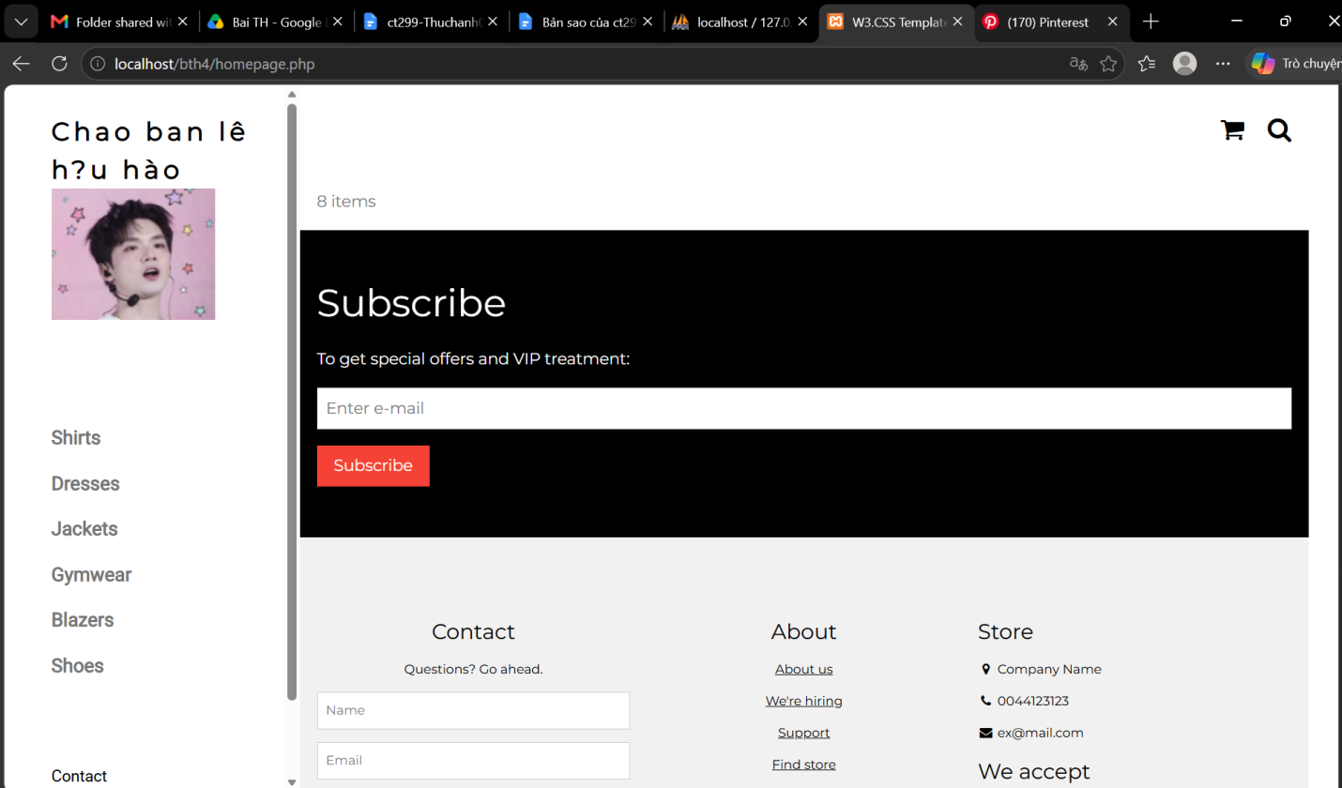
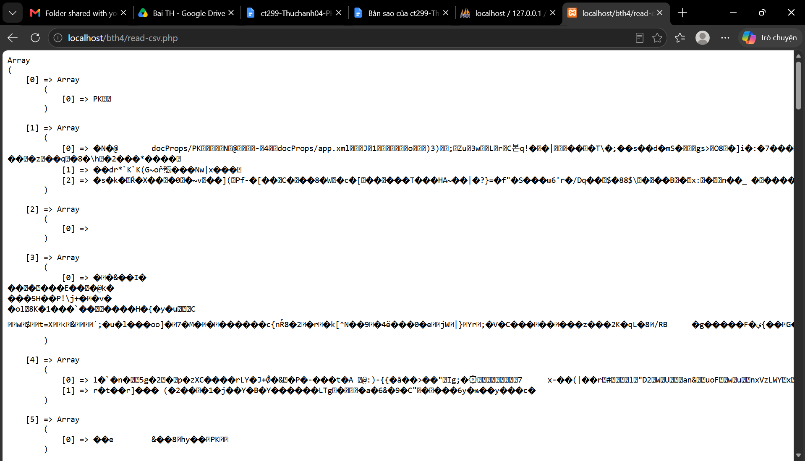

- Trong vài trường hợp, hacker có thể sử dụng các kỹ thuật SQL Injection để hack hệ thống của bạn. Bạn hãy trình bày SQL Injection là gì và thử các ví dụ trình bày trong . Ứng dụng kỹ thuật đó vào trang đăng nhập mà bạn đã tạo, chụp lại các kết quả.
- SQL Injection (SQLi) là một kỹ thuật tấn công lỗ hổng bảo mật web, trong đó kẻ tấn công chèn các câu lệnh SQL độc hại vào các trường dữ liệu đầu vào (input field) của ứng dụng. Do ứng dụng không kiểm tra hoặc làm sạch (sanitize) dữ liệu đầu vào trước khi ghép trực tiếp vào câu lệnh SQL, cơ sở dữ liệu sẽ thực thi các câu lệnh ngoài ý muốn của lập trình viên.

- Dựa vào link, bạn hãy cho biết Cookie là gì, diễn giải ý nghĩa các tham số trong setcookie(). Cách lưu, lấy, xóa giá trị trong cookie.
- Cookie là một tệp văn bản nhỏ mà máy chủ (server) gửi đến trình duyệt của người dùng (client) và được lưu trữ trên máy tính hoặc thiết bị di động của người dùng đó. Mỗi khi trình duyệt gửi yêu cầu (request) đến cùng một máy chủ, nó sẽ gửi kèm cookie này để giúp máy chủ nhận biết trạng thái, duy trì phiên đăng nhập, lưu tùy chọn người dùng hoặc theo dõi hành vi người dùng.
- diễn giải ý nghĩa các tham số trong setcookie()
$name (Bắt buộc): Tên của cookie (ví dụ: 'user_id', 'theme').
$value (Tùy chọn): Giá trị được lưu trong cookie. Giá trị này sẽ được lưu trữ ở phía máy khách, do đó không nên lưu các dữ liệu nhạy cảm như mật khẩu.
$expires_or_options (Tùy chọn): Thời gian hết hạn của cookie dưới dạng Unix timestamp (số giây tính từ ngày 1/1/1970).
- Ví dụ: time() + 3600 (hết hạn sau 1 giờ).
- Nếu để 0 hoặc bỏ qua, cookie sẽ hết hạn ngay khi đóng trình duyệt (session cookie).
$path (Tùy chọn): Đường dẫn trên máy chủ mà cookie có hiệu lực.
- Nếu đặt là '/', cookie sẽ có hiệu lực trên toàn bộ tên miền.
- Nếu đặt là '/admin/', cookie chỉ áp dụng cho thư mục /admin/ và các thư mục con của nó.
$domain (Tùy chọn): Tên miền mà cookie có hiệu lực (ví dụ: 'example.com'). Nếu muốn áp dụng cho cả subdomain, bạn đặt là '.example.com'.
$secure (Tùy chọn): Nếu đặt là true, cookie chỉ được truyền qua kết nối an toàn HTTPS.
$httponly (Tùy chọn): Nếu đặt là true, cookie chỉ có thể truy cập thông qua giao thức HTTP/HTTPS và không thể truy cập/thao tác từ JavaScript (ví dụ: qua document.cookie). Điều này giúp giảm thiểu rủi ro tấn công XSS (Cross-Site Scripting).

Cách lưu (Tạo Cookie)
Sử dụng hàm setcookie() trước khi có bất kỳ đầu ra (output) HTML hay khoảng trắng nào được gửi về trình duyệt.
<?php
// Lưu cookie tên 'username' với giá trị 'nguyenvana', hết hạn sau 1 ngày (86400 giây)
// Có hiệu lực trên toàn trang, yêu cầu HTTPS và chặn truy cập từ JavaScript
setcookie('username', 'nguyenvana', time() + 86400, '/', '', true, true);
?>

Cách lấy giá trị Cookie
Dữ liệu cookie gửi từ trình duyệt lên máy chủ được tự động lưu trong biến toàn cục $_COOKIE.
<?php
// Kiểm tra xem cookie có tồn tại hay không trước khi lấy giá trị
if (isset($_COOKIE['username'])) {
$user = $_COOKIE['username'];
echo "Xin chào, " . htmlspecialchars($user);
} else {
echo "Không tìm thấy thông tin người dùng trong Cookie.";
}
?>
- Cách xóa Cookie
Để xóa một cookie, bạn đặt lại cookie đó với cùng tên (và cùng path, domain nếu có) nhưng truyền thời gian hết hạn là một thời điểm trong quá khứ (thường dùng time() - 3600).
<?php
// Xóa cookie 'username' bằng cách đặt thời gian hết hạn về quá khứ
setcookie('username', '', time() - 3600, '/');

// Xóa giá trị khỏi biến cục bộ $_COOKIE trong phiên làm việc hiện tại
unset($_COOKIE['username']);
?>

- Dựa vào link, bạn hãy cho biết Session dùng để làm gì. Cách lưu, lấy, xóa giá trị trong Session.
- Session (Phiên làm việc) là một cơ chế cho phép ứng dụng web lưu trữ thông tin của từng người dùng trên máy chủ (server) qua nhiều trang web khác nhau trong cùng một phiên duyệt web
-Khởi tạo Session
Trước khi lưu, lấy hoặc xóa bất kỳ giá trị nào trong Session, bạn bắt buộc phải gọi hàm session_start() ở đầu file script (trước khi xuất ra bất kỳ đoạn mã HTML nào).
<?php
// Bắt đầu hoặc tiếp tục phiên làm việc Session
session_start();
?>
-Cách lưu giá trị vào Session
Gán giá trị vào mảng $_SESSION theo các khóa (key) mong muốn
<?php
session_start();

// Lưu giá trị vào Session
$_SESSION['user_id'] = 101;
$_SESSION['username'] = 'nguyenvana';
$_SESSION['role'] = 'admin';
?>
-Cách lấy giá trị từ Session
Đọc giá trị từ mảng $_SESSION sau khi đã khởi tạo session_start(). Nên kiểm tra tính tồn tại của biến bằng isset() để tránh lỗi.
<?php
session_start();

// Kiểm tra và lấy giá trị từ Session
if (isset($_SESSION['username'])) {
echo "Xin chào, " . htmlspecialchars($_SESSION['username']);
} else {
echo "Bạn chưa đăng nhập.";
}
?>
- Cách xóa giá trị trong Session
Có hai mức độ xóa Session tùy thuộc vào mục đích sử dụng:
Xóa một giá trị cụ thể (Xóa một phần): Sử dụng hàm unset().
<?php session_start();
// Xóa chỉ biến 'username' khỏi Session
unset($_SESSION['username']); ?>
Xóa toàn bộ dữ liệu và hủy Session (Đăng xuất / Clear toàn bộ): Xóa tất cả các biến Session và hủy phiên làm việc trên server.
<?php
session_start();

// 1. Xóa tất cả các biến trong $_SESSION
session_unset(); // Hoặc $_SESSION = array();

// 2. Hủy phiên Session trên máy chủ
session_destroy();
?>

- Bạn hãy so sánh Cookie và Session.
Cookie và Session đều dùng để lưu trạng thái người dùng khi duyệt web, nhưng khác nhau cốt lõi ở nơi lưu trữ và bảo mật:
Cookie lưu dữ liệu trực tiếp trên trình duyệt của bạn với dung lượng nhỏ (dưới 4KB). Cookie có thể tồn tại lâu dài ngay cả khi đóng trình duyệt, nhưng dễ bị can thiệp nên chỉ thích hợp để lưu các cài đặt nhẹ như ngôn ngữ hay giao diện sáng/tối.
Session lưu toàn bộ thông tin trên máy chủ (server) nên bảo mật cao hơn và chứa được nhiều dữ liệu hơn. Tuy nhiên, Session sẽ làm tốn bộ nhớ server và thường tự động xóa khi bạn đóng trình duyệt hoặc hết thời gian chờ.

- Chỉnh sửa các đoạn gán, khởi tạo, lấy giá trị cookie trong log.php và homepage.php thay bằng cách dùng Session. Tạo tập tin thoat.php để xóa các giá trị trong session, cookie thực hiện chức năng log out khỏi hệ thống.
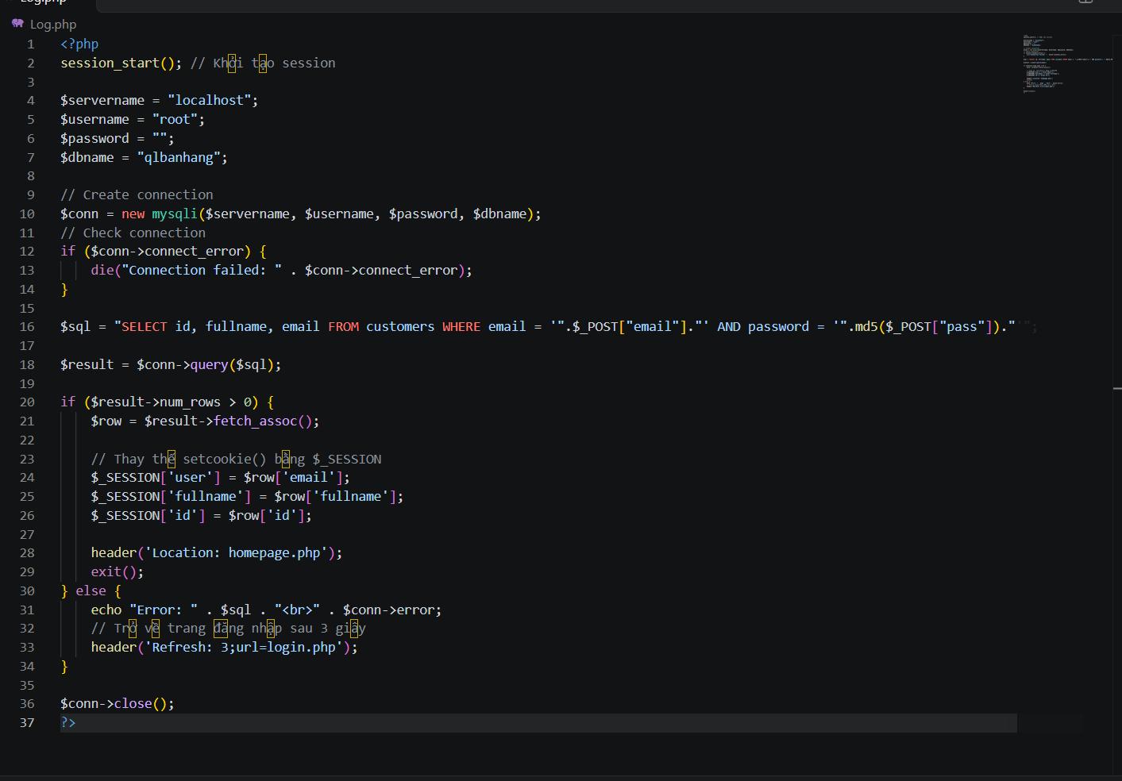

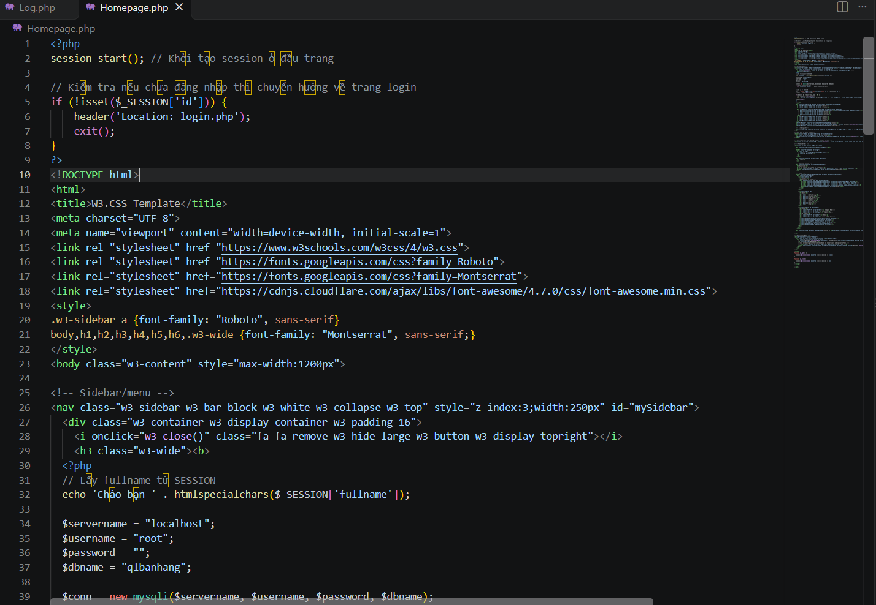
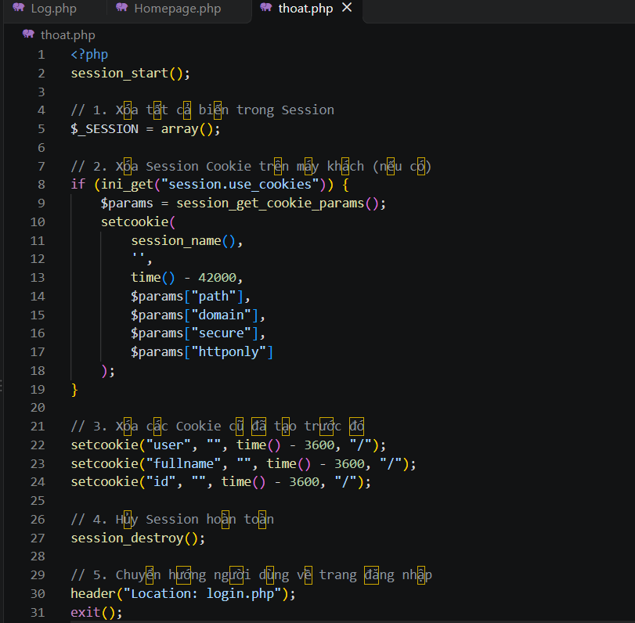

- Bạn hãy tạo form sua_mk.php cho phép người dùng chỉnh sửa mật khẩu sau khi đăng nhập. Yêu cầu gồm 3 input: ô để nhập mật khẩu cũ, 1 ô để nhập mật khẩu mới, 1 ô cho phép nhập mật lại mật khẩu mới. Khi nhập xong cần đảm bảo: mật khẩu cũ là khớp với CSDL đang lưu, 2 ô nhập mật khẩu mới phải khớp với nhau và không giống với mật khẩu cũ, nếu đáp ứng điều kiện thì tiến hành băm mật khẩu với md5 và lưu mật khẩu mới vào CSDL.
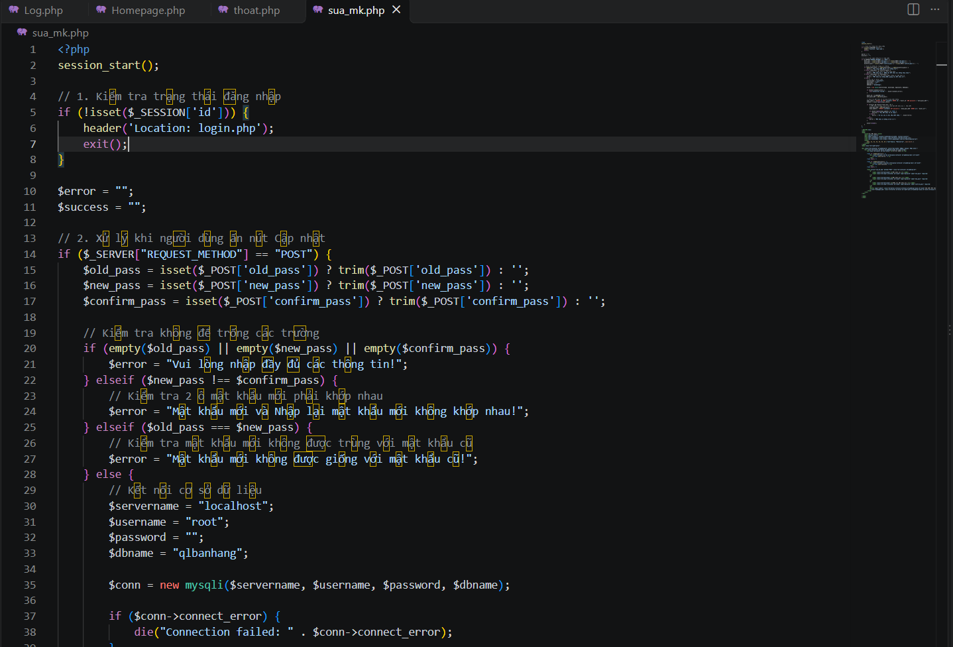

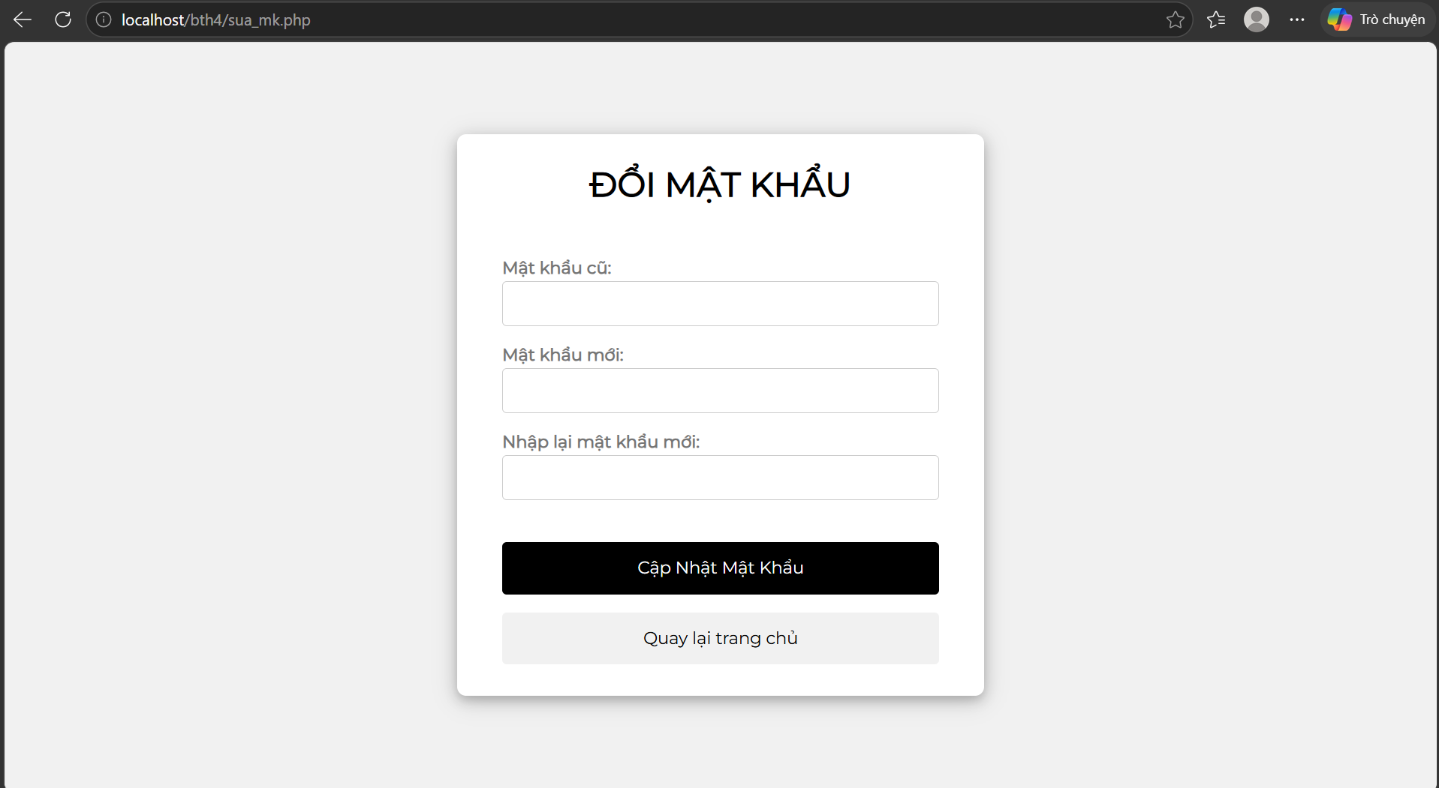

- Bạn đọc trong để tìm hiểu và mô tả các cơ chế, các hàm/thủ tục để thực hiện việc upload.
- Các cơ chế kiểm tra (Validation Mechanisms)
Đoạn mã áp dụng biến cờ $uploadOk (khởi tạo bằng 1) để quản lý trạng thái. Nếu bất kỳ bước kiểm tra nào thất bại, $uploadOk sẽ chuyển thành 0.
Kiểm tra loại file hình ảnh thật/giả:
Dùng hàm getimagesize() để đọc kích thước và kiểm tra xem tệp tạm (tmp_name) có đúng là định dạng ảnh hay không.
Kiểm tra file đã tồn tại:
Dùng hàm file_exists() để đảm bảo không ghi đè lên file đã có sẵn trong thư mục mục tiêu.
Kiểm tra dung lượng file:
Kiểm tra điều kiện $_FILES["fileToUpload"]["size"] > 500000 (giới hạn tối đa khoảng 500 KB).
Kiểm tra định dạng/mở rộng tệp (File Extension):
Lấy đuôi file và kiểm tra xem có nằm trong danh sách các định dạng được phép (jpg, jpeg, png, gif) hay không.
Các hàm và thủ tục PHP được sử dụng
basename($path): Trả về phần tên tệp từ một đường dẫn. Giúp trích xuất tên file gốc tránh các đường dẫn tương đối không an toàn.
pathinfo($path, PATHINFO_EXTENSION): Trích xuất phần mở rộng (đuôi file) từ đường dẫn tệp.
strtolower($string): Chuyển chuỗi phần mở rộng về chữ thường để so sánh chính xác (tránh sự khác biệt giữa .JPG và .jpg).
getimagesize($filename): Lấy thông tin kích thước của hình ảnh. Nếu không phải là file ảnh hợp lệ, hàm sẽ trả về false.
file_exists($filename): Kiểm tra xem file hoặc thư mục chỉ định đã tồn tại trên hệ thống tệp hay chưa.
move_uploaded_file($filename, $destination):
Đây là hàm cốt lõi để di chuyển file từ thư mục tạm (tmp_name) sang thư mục đích ($target_file).
Hàm này kiểm tra bảo mật nội bộ để đảm bảo file được di chuyển thực sự là một file được tải lên qua cơ chế HTTP POST upload.
htmlspecialchars($string): Chuyển đổi các ký tự đặc biệt thành thực thể HTML để tránh lỗ hổng Cross-Site Scripting (XSS) khi in tên file ra màn hình.

- Bạn hãy đọc, mô tả chức năng của hàm này và các tham số trong hàm (tham khảo thêm từ read-csv.php).

-Chức năng của hàm file()
Hàm file() trong PHP được dùng để đọc toàn bộ nội dung của một tệp (file) vào trong một mảng (array).
- Mỗi phần tử trong mảng tương ứng với một dòng của tệp.
- Hàm trả về mảng chứa nội dung tệp nếu thành công, hoặc trả về FALSE nếu gặp lỗi.
- Các tham số trong hàm

Tham số: path
Bắt buộc / Tùy chọn: Bắt buộc
Mô tả: Đường dẫn đến tệp cần đọc

Tham số: flags
Bắt buộc / Tùy chọn: Tùy chọn
Mô tả: Cờ điều khiển (FILE_USE_INCLUDE_PATH, FILE_IGNORE_NEW_LINES, FILE_SKIP_EMPTY_LINES)

Tham số: context
Bắt buộc / Tùy chọn: Tùy chọn
Mô tả: Tập hợp các tùy chọn để chỉnh sửa hành vi của luồng dữ liệu (stream context)

- Bạn hãy tạo 1 tập tin csv ít nhất 10 dòng dữ liệu với các cột dữ liệu như bảng customer trong csdl qlbanhang. Tạo tập tin upload-csv.php với giao diện cho phép upload các tập tin csv, và tập tin upload-csv-processing để xử lý nút xử lý sự kiện upload file csv và đưa dữ liệu vào bảng customers trong CSDL. Gợi ý:
  - Xem cấu trúc của bảng customer, mở excel và nhập liệu lưu lại với định dạng CSV.
  - Tham khảo upload-img.php để thiết kế giao diện upload file
  - Tham khảo upload-csdl.php để thiết kế action xử lý việc upload file, chú ý chỉnh sửa loại tập tin chấp nhận các file csv. Tham khảo: ,. Ở đoạn sau khi upload thành công, bạn lấy tên file vừa upload đưa vào hàm đọc tập tin. Bạn tham khảo read-csv.php chỉnh sửa đọc dữ liệu từ csv đưa vào mảng để lần lượt thực hiện insert từng dòng dữ liệu trong csv vào CSDL.

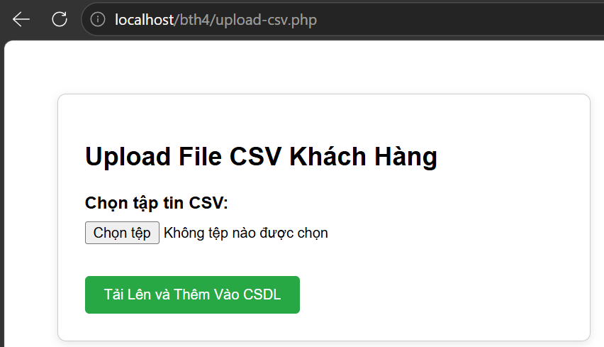
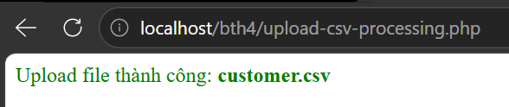

Chú ý:
- Các bạn nộp file word: Đặt tên file: <mssv><hoten><bai4>.docx nộp lên classroom, kèm với các file code đã tạo (ngoại trừ file word trả lời câu hỏi, các file còn lại các bạn nén vào file .zip).
- Mỗi câu các bạn trả lời bằng hình/trả lời dạng text tùy vào yêu cầu của câu hỏi, và ghi rõ số thứ tự câu hỏi mà bạn trả lời.
- Các bài phát hiện copy từ các bài của bạn khác sẽ không được tính điểm.
- Chú ý: Các câu trả lời có tham khảo trên Internet phải trích dẫn link

https://www.w3schools.com/sql/sql_injection.asp
https://www.w3schools.com/php/php_cookies.asp
https://www.w3schools.com/php/php_sessions.asp
https://www.w3schools.com/php/php_file_upload.asp
https://www.w3schools.com/php/func_filesystem_file.asp
https://www.php.net/manual/en/features.file-upload.post-method.php,
https://stackoverflow.com/questions/6654351/check-file-uploaded-is-in-csv-format

